**3) Home Comfort**

**Webservices/API:**

* The geocode function supported by the browser has been used to detect user’s current location.
* The weather webservice by wunder “api.wunderground.com” has been used to populate the outside temperature and humidity.
* The jQuery UI sliders have been used for creating sliders on the home comfort page.
* The “google.visualization.Gauge” has been used to create the comfort index gauge.
* The text to speech service from tts.com has been used to convert to written recommendations to speech.

**Design & Implementation details:**

User Clicks on the Home Comfort Image.

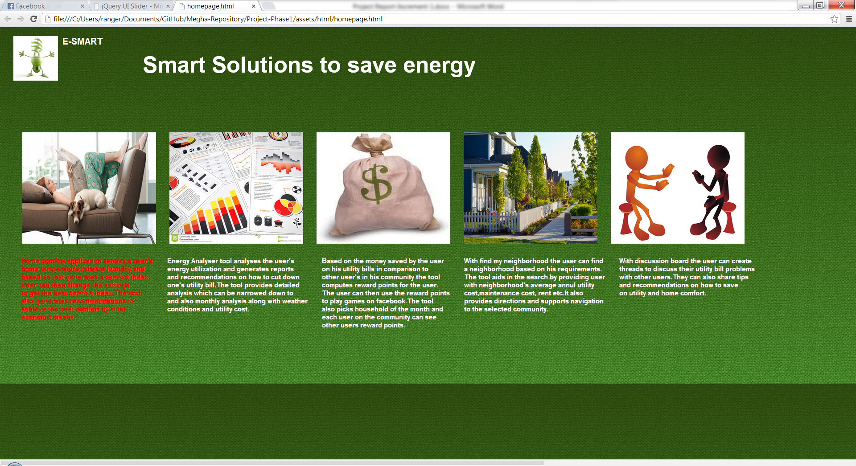

The Page displays the user’s current home temperature and humidity and computes the Comfort Index (Comfort Index computation using formulae is yet to be implemented) of his home environment. This page also shows the outside temperature and humidity and displays a message providing an explanation of the comfort index.

If the comfort index is outside the comfort zone (in green) then it also shows a set of recommendations to make the comfort index fall into green zone. These recommendations are created by performing computation on his current home environment.

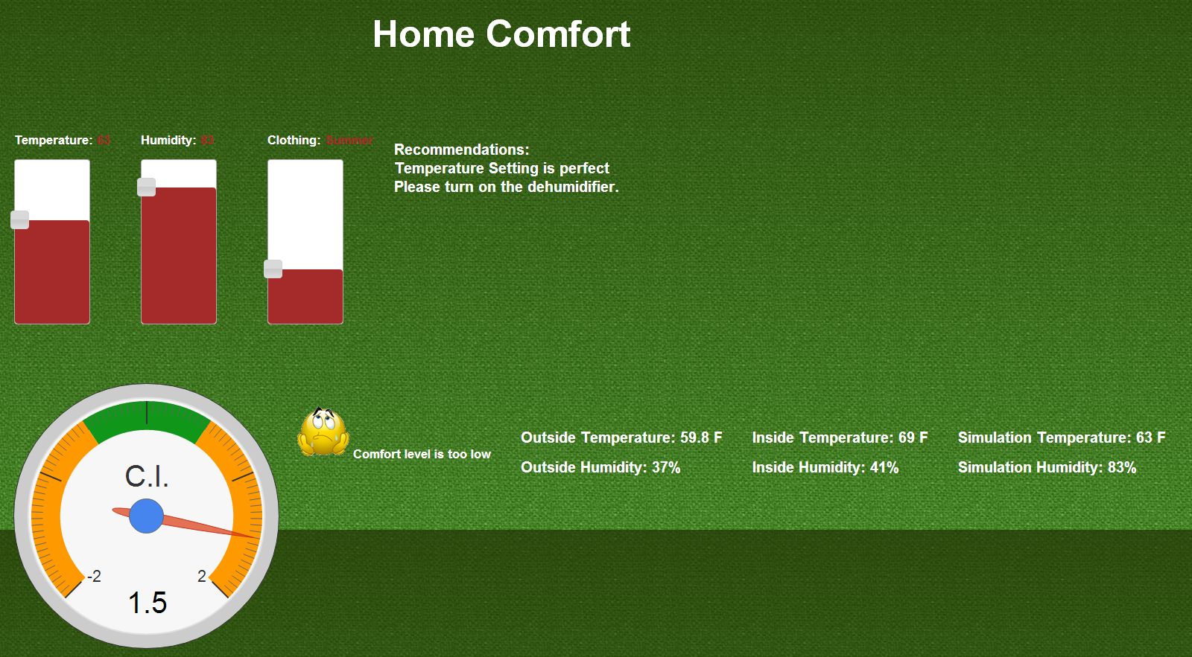

The user then tries to change the temperature, humidity and clothing based on the recommendations and a new comfort index is computed and displayed. The comfort index is now in the green zone so the user’s home environment is now comfortable.

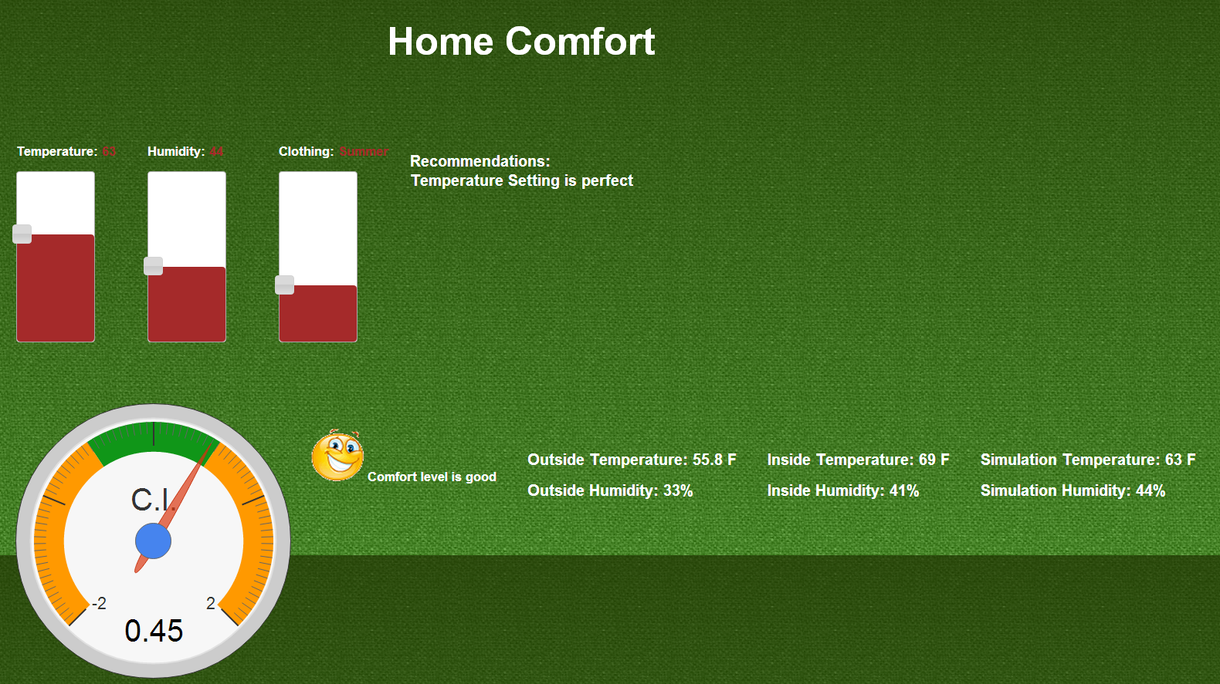

If the user sets the temperature too high or too low then the system prompts an alert message.

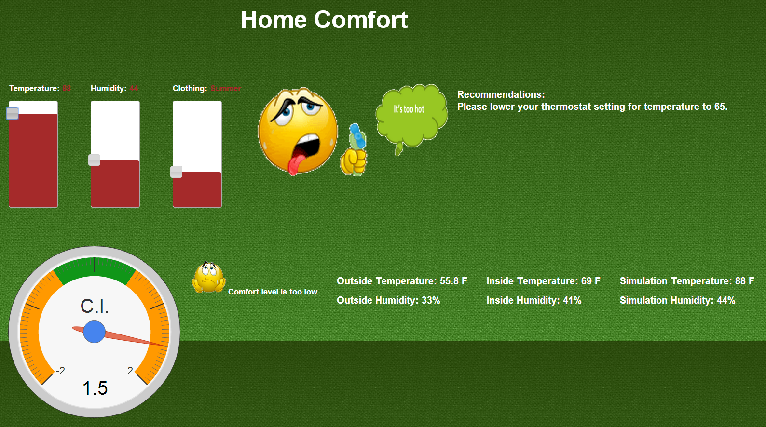

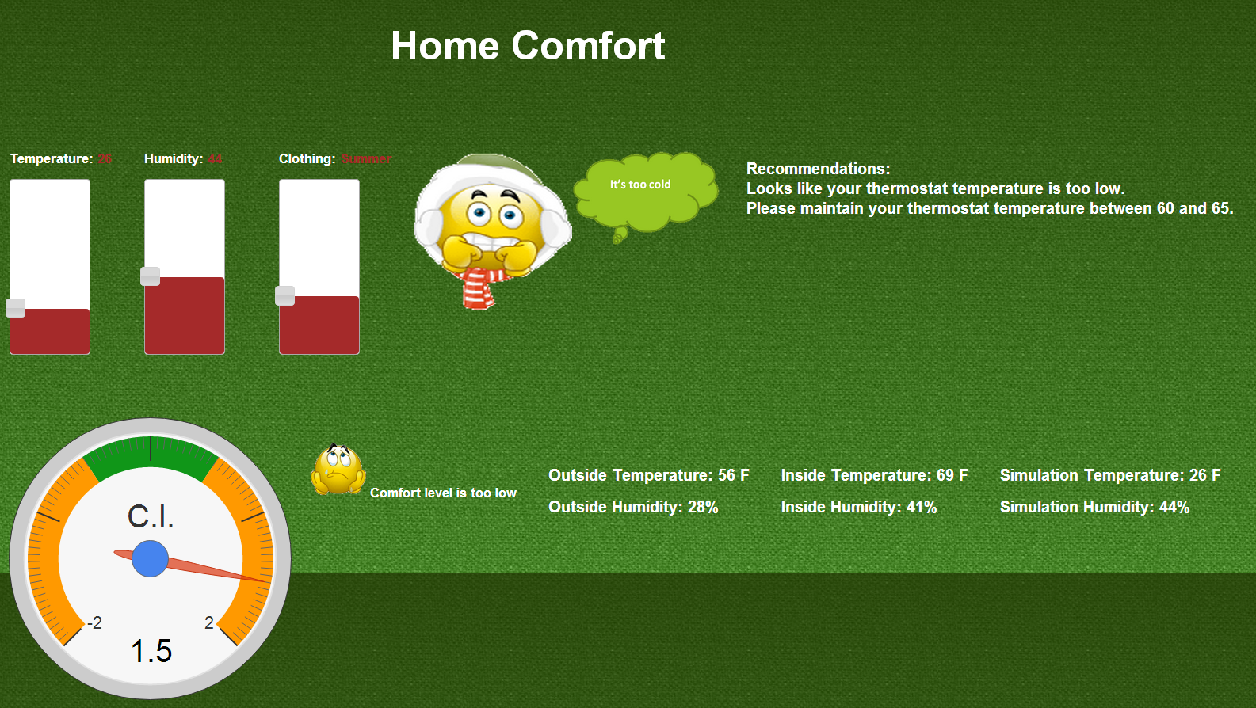

**6) Survey based Budget my year, Recommendation and Tip of the day**

**Webservices/API:**

* In future we will be using EnergyStar API to determine each appliance’s approximate energy consumption.
* Google visualization api has been used to generate charts.
* jQuery toggle used in recommendations page.

**Design & Implementation details:**

User clicks on the Budget My Year option which takes him to the survey page.

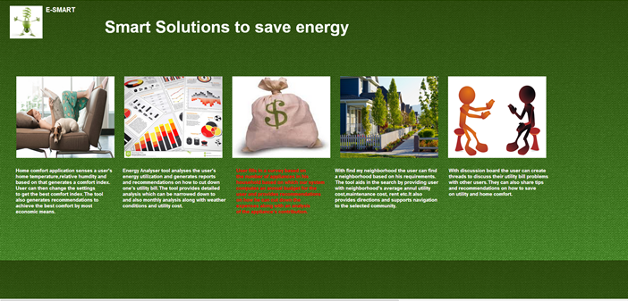

Below is the survey page where user can gets the options to fill household survey and Appliance Information.

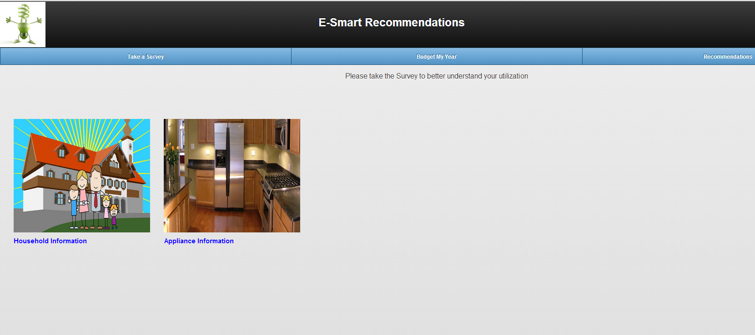

Below is the Household information part of the survey.

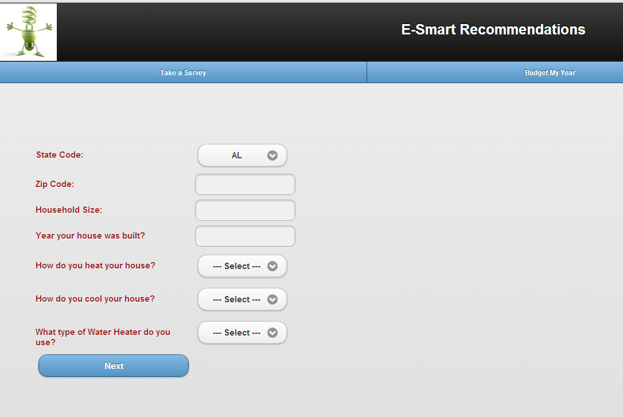

The next page takes him to the appliance based survey.

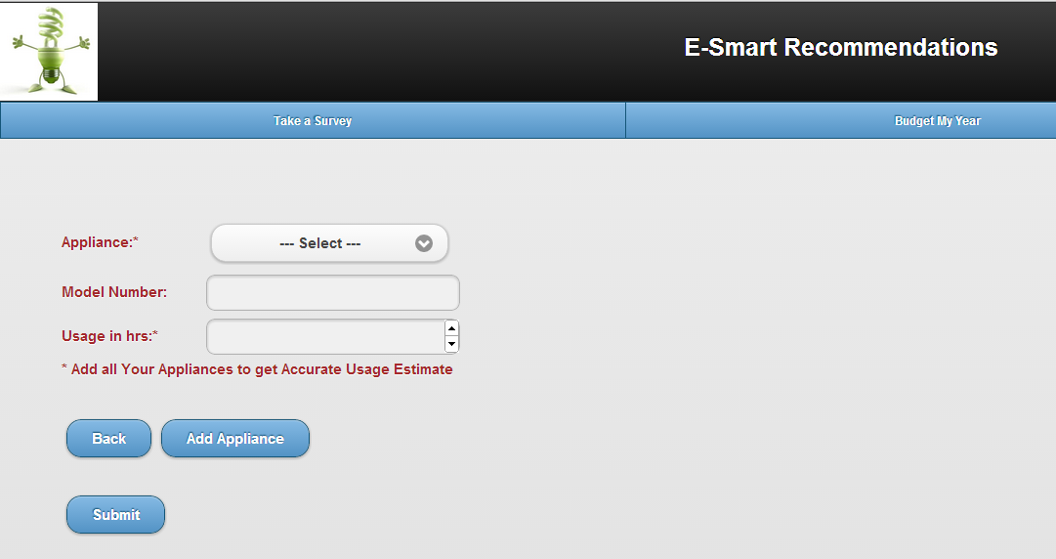

After entering all the appliances and clicking on submit, the system displays the below page.

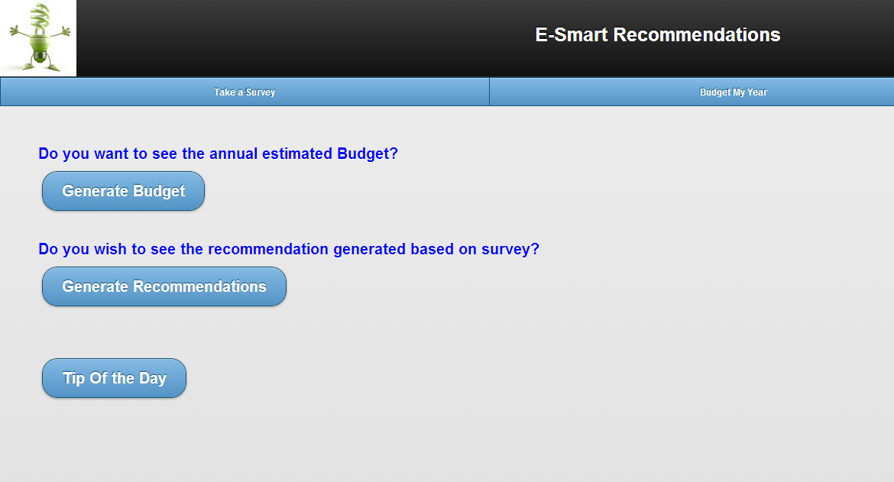

On clicking generate Budget, the system computes the user’s estimated budget generated based on the survey.

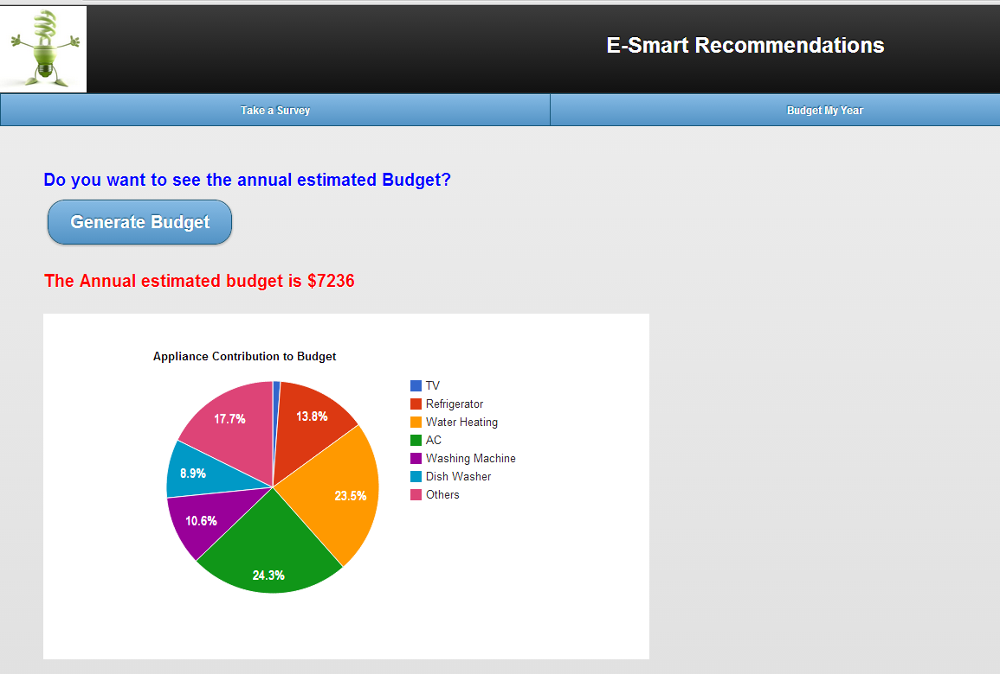

Clicking on generate recommendations takes him to another page which displays a set of appliance utilization recommendations generated based on the survey. A toggle feature in jQuery is used while designing this application. User can have a choice of selection which appliance recommendation he needs.

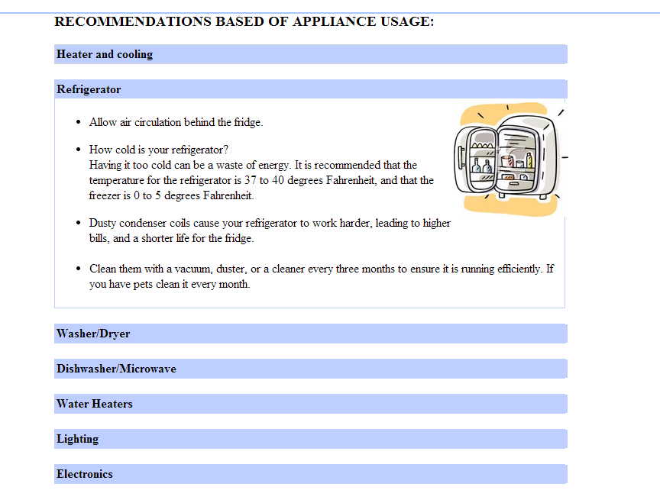

User can also choose to see the tip of the day.

